**STM32 Starter Kit**

This document details the STM32 Starter Kit parts and components. This will be used as a design reference for the PCB and Components assembly.

Table of Contents

1. STM32 Microcontroller 2

2. GPIO Digital Inputs 3

3. GPIO Digital Outputs 4

4. Analog Inputs 5

5. Boot configuration 6

6. Counter Display 7

7. RGB LED 8

8. Rotary Encoder 9

9. TTL To USB Converter 10

10. RFID Module 11

11. MPU6050 IMU 12

12. SD Card 13

# STM32 Microcontroller

The STM32F103 Bluepill will be used

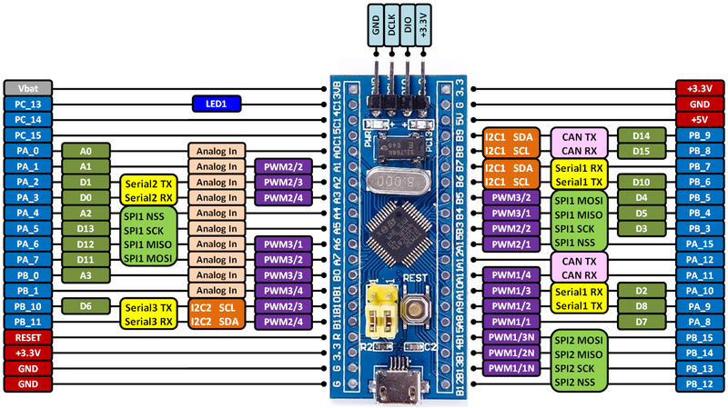

# GPIO Digital Inputs

Digital inputs include the following

* User/Wakeup push button
* Tamper push button
* Joystick push button (indirect)
* Slide switch x2

STM32 pinouts table:

|  |  |  |
| --- | --- | --- |
| **Functionality** | **STM32 pin** | **Comments** |
| **User/Wakeup** | PA0 |  |
| **Tamper** | PC13 |  |
| **Joystick** | PB3 |  |
| **Slide Switch 1** | PA8 |  |
| **Slide Switch 2** | PA15 |  |

# GPIO Digital Outputs

We have 4 digital outputs, 4 LEDs.

|  |  |  |
| --- | --- | --- |
| **Functionality** | **STM32 pin** | **Comments** |
| **LED1 - Green** | PB13 | TIM1-CH1N: OC Output |
| **LED2 - Red** | PB14 | TIM1-CH2N: OC Output |

# Analog Inputs

We have 3 Analog inputs; Potentiometer, 2-axis joystick, and an electret microphone

|  |  |  |
| --- | --- | --- |
| **Functionality** | **STM32 pin** | **Comments** |
| **Potentiometer** | PA1 |  |
| **Joystick - x** | PA2 |  |
| **Joystick – y/Electret Mic** | PA3 | This pin is shared between Microphone and Joystick - y |

# Boot configuration

Add a push button to hold Boot-0 pin high momentarily while reset. Have boot pin connector to PCB via jumper wire.

We require Boot-0 pin to be jumped to PCB via a single wire, then have a button that pulls it high momentarily. Also have an adjacent reset button.

# Counter Display

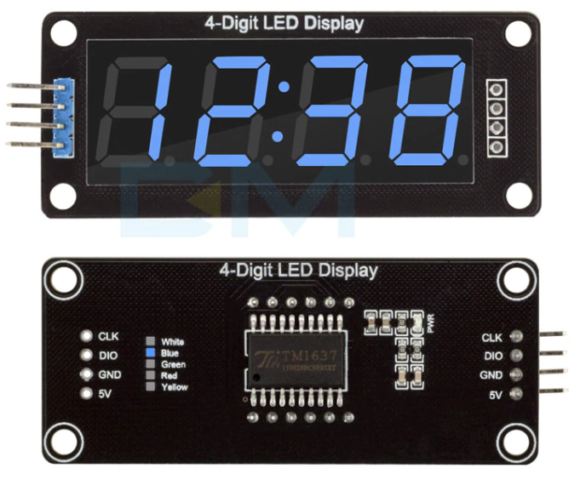A 4-bit 7-segment of a cool color will be used as a counter display and for displaying RTC Time.

The following are the required pinouts:

|  |  |  |
| --- | --- | --- |
| **Functionality** | **STM32 pin** | **Comments** |
| **CLK** | PB10 | I2C but without Slave Address |
| **DIO** | PB11 |  |

# RGB LED

RGB LED is used to demonstrate PWM functionality. The following are its pinouts:

|  |  |  |
| --- | --- | --- |
| **Functionality** | **STM32 pin** | **Comments** |
| **R** | PB4 | TIM3_CH1 PWM |
| **G** | PB5 | TIM3_CH2 |
| **B** | PB0 | TIM3_CH3 |

# Rotary Encoder

Rotary encoder will be used to demonstrate the TIM-IC capability. The following are the required pinouts:

|  |  |  |
| --- | --- | --- |
| **Functionality** | **STM32 pin** | **Comments** |
| **A** | PB6 | TIM4_CH1 |
| **B** | PB7 | TIM4_CH2 |

# TTL To USB Converter

TTL to USB converter will be used to enable PC VCP.

|  |  |  |
| --- | --- | --- |
| **Functionality** | **STM32 pin** | **Comments** |
| **RXD** | PA9 | USART1_TX |
| **TXD** | PA10 | USART1_RX |

# RFID Module

RFID is an SPI device. The following are its pinouts:

|  |  |  |
| --- | --- | --- |
| **Functionality** | **STM32 pin** | **Comments** |
|  |  |  |
| **CS** | PA4 |  |
| **SCK** | PA5 | Shared with SD Card |
| **MOSI** | PA7 |  |
| **MISO** | PA6 |  |

# MPU6050 IMU

The IMU sensor is used to demonstrate I2C functionality. The following are its pinouts:

|  |  |  |
| --- | --- | --- |
| **Functionality** | **STM32 pin** | **Comments** |
| **SCL** | PB8 |  |
| **SDA** | PB9 |  |
| **INT** | PB12 |  |

# SD Card

SD Card is connected through SPI, shared with RFID interface SPI. The following are the pinouts:

|  |  |  |
| --- | --- | --- |
| **Functionality** | **STM32 pin** | **Comments** |
| **SPI_SCK** | PA5 | SPI is shared with RFID |
| **SPI_MISO** | PA6 |  |
| **SPI_MOSI** | PA7 |  |
| **SPI_CS** | PB1 |  |